**Describing and comparing all-cause mortality trends in Scotland with other high-income nations (1981-2017)**

Lynda Fentona 1 2, Jon Minton1, Julie Ramsay3, Maria Kaye3, Gerry McCartney1

1. Corresponding author: [lynda.fenton@nhs.net](mailto:lynda.fenton@nhs.net)
2. Public Health Observatory, NHS Health Scotland, 5 Cadogan Street, Glasgow, Scotland, G2 6QE.
3. Public Health, NHS Greater Glasgow and Clyde, West House, Gartnavel Royal Hospital Campus, 1055 Great Western Road, Glasgow, G12 0XH.
4. National Records of Scotland, Ladywell House, Ladywell Road, Edinburgh, Scotland, EH12 7TF.

**Abstract**

**Background**

Mortality rates have increased, and life expectancy decreased, in several high income countries over the last five years. This study aims to describe the nature, scale and timing of changes in mortality in Scotland, and to compare the trend to those seen internationally, as an early step in understanding the causes of the trends.

**Methods**

**Results**

**Conclusion**

**Key Words**

Mortality, Life expectancy, Scotland, Europe, trend, austerity, influenza.

|  |
| --- |
| **Summary box** |
| **What we already know** |
| **What this study adds** |

**Background**

Mortality rates have steadily declined, and life expectancy at birth steadily improved, across most high income countries since 1945.[1] [2] There have been exceptions to this general trend, including the countries of Eastern Europe during the 1990s1 [3], and nations at war or with substantial civil conflict.[4] However, there has been a series of reports that these improving trends are now faltering, or even worsening, for the USA, the UK and its constituent nations, and much of continental Europe, since around 2012.[5][6]-[7]

In line with the earlier availability of data, the initial analyses on this problem used crude death counts, then crude mortality rates, age-standardised mortality rates and life expectancy figures. Given the ageing of the populations in high income countries, it is important not to use broad age bands to account for changes in the population structure or different standard populations for different parts of a time series, as these could fail to adequately account for population ageing or create artefactual discontinuities in the trends.[8] [9] However, the crude counts and crude rates are generally available prior to the fully age-standardised mortality rates and life expectancy figures, and these are continuing to show a high number of deaths in many European countries for 2018 (e.g. see [www.euromomo.eu](http://www.euromomo.eu) for crude mortality trends).[10]

Of a selection of 18 high income countries, life expectancy declined most in Italy, Belgium, Germany, France, the UK, Spain, the Netherlands and the USA in 2014-6, with increases in Finland, Japan, Australia, Norway, Canada and Denmark.5 Countries with declining life expectancy generally had increased mortality in those aged >65 years and due to deaths from respiratory disease and cardiovascular disease. There was a more complex picture in the USA however, where increased midlife mortality risk, due to external causes such as drug-related deaths,5 [11] was a primary determinant of falling life expectancy for males, whereas increased mortality in older age was the main drive of falling life expectancy for females. However, the short-run trends in mortality rates and life expectancy, even at national level, can vary substantially from year to year and can be very sensitive to the comparison period.[12] Care is therefore required in describing the trends, when they may have changed, and in interpreting trends using emerging data which may be modelled or crude.8 [13]

Several hypotheses have been proposed to explain the changes in trends. It is possible that different factors are important for different populations, but it seems more likely that factor that are common to all of the countries displaying similar trends, and which is absent in countries without the change in trend, are causal.[14] It is also likely that several factors acting together are relevant to explaining the trends, whether that is some aspect of the context (such as underlying political economy within a country) or two specific factors interacting. Many of the hypotheses proposed thus far are not mutually exclusive, but that does not mean that they are all causal factors or carry the same importance.

Cohort effects, whereby a particular generation is found to be at higher risk of mortality, may be important if that generation is now reaching an age where it contributes more to the overall mortality and life expectancy statistics. Other possibilities are that there is an interaction between period effects (such as policy changes or infectious disease epidemics) and vulnerabilities within a cohort such that mortality for that group increases. This has been observed for specific causes of death in Scotland and the USA (for suicide, drug-related deaths and alcohol).[15][16][17]-[18]

The polarisation of the debate regarding causes of stalled life expectancy may not be helpful for supporting effective public health action to address it. Much of this apparent polarisation may be attributable to seeking the answers to different questions (for example causes of high numbers of deaths in short periods of time or stalling of overall life expectancy) and in the variable comparator, or baseline, periods employed. All of the studies proposing or investigating the change in trends have been limited to a degree by a lack of clarity on the timing, rapidity and degree of change in the trends – all factors that can help in causal investigation.14

This study aims to describe the nature, scale and timing of changes in mortality in Scotland, and to compare the trend to those seen internationally, as an early step in understanding the causes of the trends.

**Methods**

We report our results in accordance with the RECORD guideline.[19]

**Data sources**

We used data from the Human Mortality Database (HMD)[20] for all our analyses except for the segmented regression and decomposition analyses which used data held by National Records of Scotland (NRS). All analyses were undertaken for males and females separately. The annual data trends will be different from the published data using 3-yearly rolling averages. Where we have used annual or quarterly data, we have done so to provide the maximum number of data points to identify turning points in the trends. The data in this form are often not how they are presented by national statistics agencies because they are at risk of substantial random year-to-year variation. This variation should therefore be interpreted very cautiously.

**Life expectancy trends**

Period life expectancy trends for Scotland for each single year between 1855 and 2016 were extracted. For the international comparisons, data for all countries with a total population of >2million and with data available from 1992 to 2016 (inclusive) at the time of extraction were obtained via the HMD. The mean annual change in life expectancy (in weeks) for five year periods running back from 2016 were then calculated for each country. A sensitivity analysis using rolling five-year time periods rather than set periods from 2016 backwards was also undertaken.

**Age-specific mortality rates**

Data were extracted from the HMD for Scotland, England & Wales, France and the USA for this analysis. The mortality rates at each single year of age for every year from 1981 to 2016 were calculated. A small correction of five was added to the numerators and denominators before calculating age-specific mortality rates to avoid the impacts of zero figures. Each age-specific mortality rate was then indexed to its value in 1981 and multiplied by 100 so that a value of 110 means a death rate 10% higher than that in 1981. These age-specific mortality indices were then weighted to produce indices for a smaller number of broader age categories that would avoid artefacts due to changes in the age structure within each age stratum, as follows. First, each age in single years was assigned to a broader age category comprising multiple ages in single years. Second, the proportion of the population at each age in single years within each specific broad age category, in each specific year, was calculated to produce a within-category weighting factor. Finally, for each year, and each age category, the age-specific mortality indices were multiplied by the weighted factors, then summed, in order to produce a year-specific population weighted mortality index for that age group.

**Segmented regression**

We calculated age-standardised mortality rates for each quarter of each year for Scotland using the 2013 European Standard Population for the entire time period, and then created rolling trends which pooled the named quarter with the three previous quarters. In this way, quarter 1 (Q1) in 2016 pools the data for 2015 Q2-4 with 2016 Q1. We then undertook segmented regression in R using the ‘segmented’ package. We ran this for one and two break point models for all men, all women and for men and women divided into <75 years and 75+ years. We then calculated the Akaike Information Criterion (AIC) and Bayesian Information Criterion (BIC) to compare model fit between one and two break models.

**Decomposition of change of life expectancy by age and cause of death**

? to be included in this paper

**Results**

**Life expectancy trends**

Figure 1 shows the period life expectancy at birth for men and women in Scotland from 1855 to 2016, based on single year estimates. Throughout the time period women have longer life expectancies than men. The trend up to around 1945 is substantially more unstable than in later years, but there is a general long-term improvement evident, especially after 1890. From 1950 onwards, the degree of year-to-year variability reduces and the improvement is a slower rate than between 1890 and 1950.

**Figure 1 – Period life expectancy at birth, men and women, Scotland, 1855-2016**

The mean annual change in life expectancy observed within 5 year periods (between 1857 and 2016) shows that the largest annualised gains were made in the years following declines in life expectancy (e.g. 1942-1946), with steadier and more modest improvements from the mid-1950s onwards (Figure 2). Between 2012 and 2016, only small mean annualised life expectancy improvements were observed: 2.5 weeks for women and 4.5 weeks for men. In the post-1945 period, this is the smallest 5-year average annual increase seen for women, and there were only two periods with smaller gains for men (1957-61 and 1972-76). A sensitivity analysis (not shown) using rolling 5-year periods identifies similar results and this is not dependent on the selection of the start and finish years.

**Figure 2 – Mean annual change in period life expectancy at birth (weeks) for 5 year periods, men and women, Scotland, from 1857-2016**

Figure 3 shows the annual period life expectancy data for Scotland, Northern Ireland and for England & Wales combined. For all populations, female life expectancy was higher than for males, with figures highest for England & Wales and lowest for Scotland with Northern Ireland in-between. There is evidence of a stalling or reversal in trends in all populations, but the extent and timing is variable. The trends for England & Wales are less variable year-on-year, reflecting the larger population.

**Figure 3 - Period life expectancy at birth, men and women, Scotland, England & Wales, Northern Ireland, 2006-2016 (note curtailed y-axis)**

To identify the nations and time periods with the greatest change in life expectancy trends, the mean annual changes in life expectancy (in weeks) for the selected countries are shown in Figures 4 and 5 for females and males respectively. All countries for all time periods saw increases in life expectancy over the five year time periods with the exception of Belarus (1992-2001 for men and 1992-1996 for women) and the USA between 2012 and 2016 for men.

For women, the smallest increases in life expectancy between 2012 and 2016 was in England & Wales (1.1 weeks/year), followed by the USA (1.9 weeks/year), Scotland (2.5 weeks/year), the Netherlands (2.7 weeks/year), France (3.4 weeks/year) and Sweden (4.4 weeks/year). The largest increases for 2012-2016 were in Belarus (23.4 weeks/year), Japan (13.3 weeks/year), Czech Republic (10.5 weeks/year), Denmark (10.0 weeks/year), Poland (10.0 weeks/year), Switzerland (5.7 weeks/year) and Austria (5.3 weeks/year). The increases between 1997 and 2001 were substantially higher than for the subsequent time period for all countries except for the Czech Republic, Japan and Belarus (Figure 4). The trends for Japan and Belarus are particularly different than for the other countries: Japan had a period of stagnating life expectancy earlier than all others in this analysis but subsequently increased in line with historical trends; Belarus has seen increasingly rapid improvements over time but starting from a declining starting point in the early 1990s.

Amongst men, the smallest increases in life expectancy between 2012 and 2016 was in the USA, England & Wales, Scotland, the Netherlands, Sweden and France with increases of -0.4, 4.0, 4.5, 7.1, 8.0 and 9.4 weeks/year respectively. The largest increases were in Belarus, Japan, Czech Republic, Poland, Denmark, Switzerland and Austria, with increases of 44.2, 16.1, 13.8, 13.7, 13.0, 12.9 and 11.1 weeks/year. Similar to the trends for women, the increases for the latest period were smaller for the latest period than for between 1997 and 2011 for all countries except Japan and Belarus (where again there was an earlier period of stagnation in Japan and where the improvements have accelerated over time for Belarus) (Figure 5). There is no clear pattern for women nor men whereby the countries with the highest life expectancy have had the smallest improvements (Figure 6).

**Figure 4 - Mean annual change in female life expectancy at birth (weeks) for five year periods (1991-2016, left axis), and current life expectancy (right axis)**

**Figure 5 - Mean annual change in male period life expectancy at birth (weeks), 5 year periods 1991-2016, and current life expectancy (secondary axis), selected countries**

Figure 6 – to be added – correlation of LE and annualised gains for the latest period.

**Age-specific mortality rates**

Weighted mortality rate indices have fallen faster amongst 0-14 year olds than amongst any other age groups, for males and females, in every country except Scotland since 1981 (Figures 7 & 8). By 2016, mortality rates fell to between 60-70% of their 1981 rates in Scotland, compared to around 30-40% in France, and 40-50% in England & Wales and the USA. The improvements amongst those aged 15-34 years have been generally less than for other age groups, and were particularly unfavourable in Scotland until the late 2000s.

Whereas the trends in most other age groups have been towards considerable improvements ( falling mortality rates) since 1981, in this age group there is more evidence of stalling in the other countries, and worsening in Scotland. The table below shows how index values in this age group compares in the eight population groups of interest. Mortality rates in these age groups were between a tenth and an eighth higher in Scotland by 2000 compared with 1981, and by 2016 fell only marginally for women, and to around 85% of their 1981 values in Scotland. At their peak, in the late 1990s/early 2000s, mortality rates in males were around a fifth higher, and in females a tenth higher, than in 1981.

Trends had also stalled in the USA throughout the 1980s, before falling in the early/mid 1990s. Mortality rates also remained stalled in England & Wales for males, before improving in the mid/late 1990s, and continued to improve for females; by 2016 mortality rate improvements had become roughly equal for both gender. In France, the mid 1990s marked an acceleration in improvements for both genders, which continued in subsequent periods, such that by 2016 mortality rates in this age group were less than half their level in 1981.

Mortality rate improvements in the middle of working age have tended to be more persistent in this age group than in the 15-34 year old age group, with more gradual improvements observed in each country and both genders. However, it is also within this age group that sudden changes towards either stagnation (England/Wales) or worsenings (Scotland, and to a lesser extent USA) since around 2012 can be observed. The increase in mortality rates between 2010 and 2016 can be seen in the graphs above, and the table below. In Scotland, mortality rates in this age group increased by almost a tenth in both males and females between 2010 and 2016. In the USA, they increased by around an eighth. Over the same period, they fell by around 5% in England & Wales, and around 15-20% in France.

Mortality rates in this age group have seen the fastest rates of improvement in Scotland since 1981, compared with other popualtion groups, but have been stalling in recent years. They fell by around 10-15% from 1981 to 1990, by around 20% from 1990 to 2000, by around a quarter from 2000 to 2010, but by only around 8-10% between 2010 and 2016. Though this latter comparison is of a shorter time period, a slowdown in the trends seems evident from the figures.

Similar slowdowns are also seen in England & Wales, and France, and flattening mortality improvements have been observed in the USA.

Within the 75-89age band, the relative improvements between 1981 and 2016 were larger for males than females in Scotland (51 for males compared with 63 for females), in England & Wales (49 compared with 57), and in the USA (61 comapred with 73), whereas in France the index of improvement was slightly greater in females (44) than males.

There have been very consistent trends in mortality rate improvement in both genders and all four countries in this age group. However, annual rates of improvement have been more modest in recent years. The table below shows the average change in the index values for each of the eight population groups over the 1980s, 1990s, 2000s, and between 2010 and 2016. With the exception of females in the 1980s, average rates of annual improvement have been substantially less in the 2010-2016 period than in earlier decades. In Scotland, annual improvements in the 2000s were around three times larger than improvements over this latter period in women, and around twice as large in men. The equivalent relative improvement ratios, were around 2.6 times (females) and 3.0 times (males) in England & Wales, 1.7 (females) and 1.4 (males) in France, and around 2.5 times greater in the USA for both males and females. Though there have not been clear increases in mortality risks in this age group, because a large proportion of all deaths that occur, tend to occur in these age groups, the clear slowdown in improvements in this age group is likely to be an important driver of falling and stalling life expectancies. The international comparison shows that, unlike the trends in some younger age groups, this phenomenon is not specific to Scotland.

90+The table below shows the index values for this age group in each of the population groups. General tendencies towards continually improving mortality at these ages were observed for Scotland, England & Wales, and France since the early 1980s, but not in the USA, where mortality rates increased modestly until the early 2000s, before starting to fall. In Scotland, England & Wales, and France there are indications of stalling improvements after around 2010-2012, consistent with that observed in the previous age groups, whereas trends in the USA are continuing to improve as they catch up towards the other three countries. The table below shows the average annual change in index values over the 1980s, 1990s, 2000s, and the period 2010-2016. This illustrates some additional complications in the trends. As with males and females in the USA, there is some evidence of ‘catch up’ in the latest period for males in Scotland, with a higher average rate of improvement for males in the 2010s than the 2000s; for Scottish females, the rates of improvement are similar in the 2010s than the 2000s.

In France, and in England & Wales, average rates of improvement in the 2010s were considerably smaller than in the 2000s, whereas improvements accelerated over the latter compared with previous period for both genders in the USA.

**Figure 7 – Age-specific mortality rates indexed to 1981, females, weighted by age structure within each age stratum**

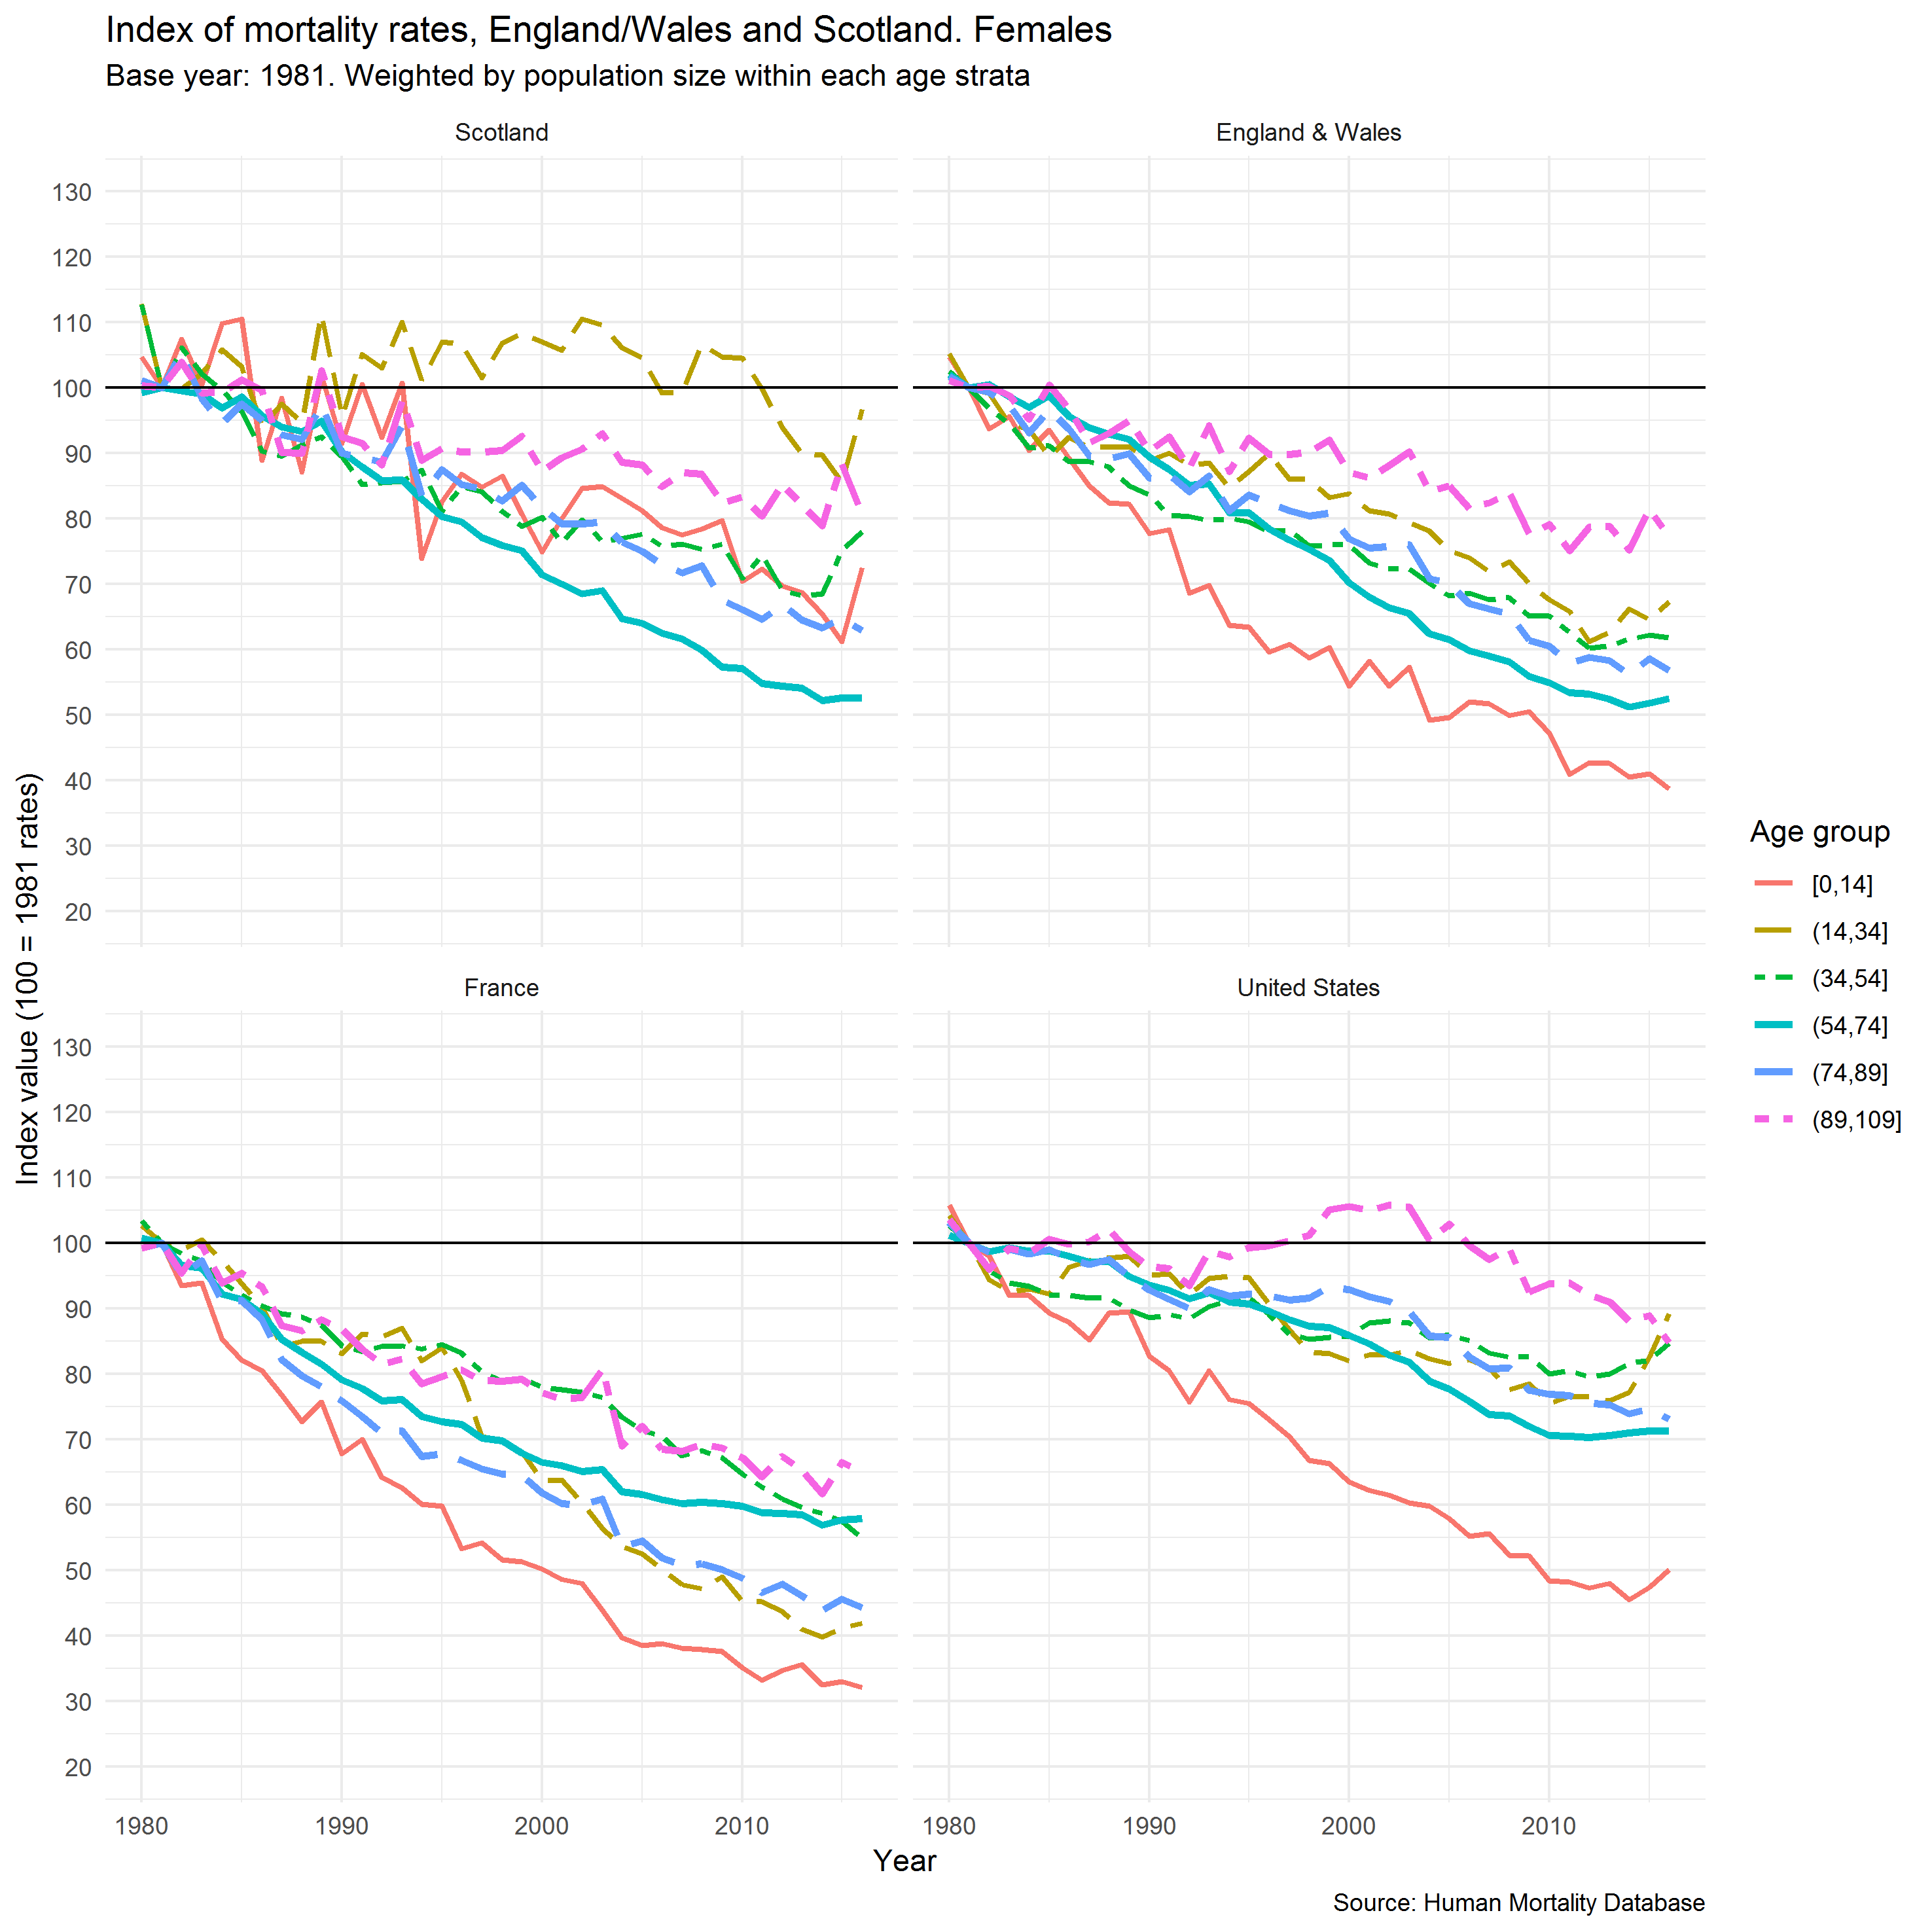

**Figure 8 – Age-specific mortality rates indexed to 1981, males, weighted by age structure within each age stratum**

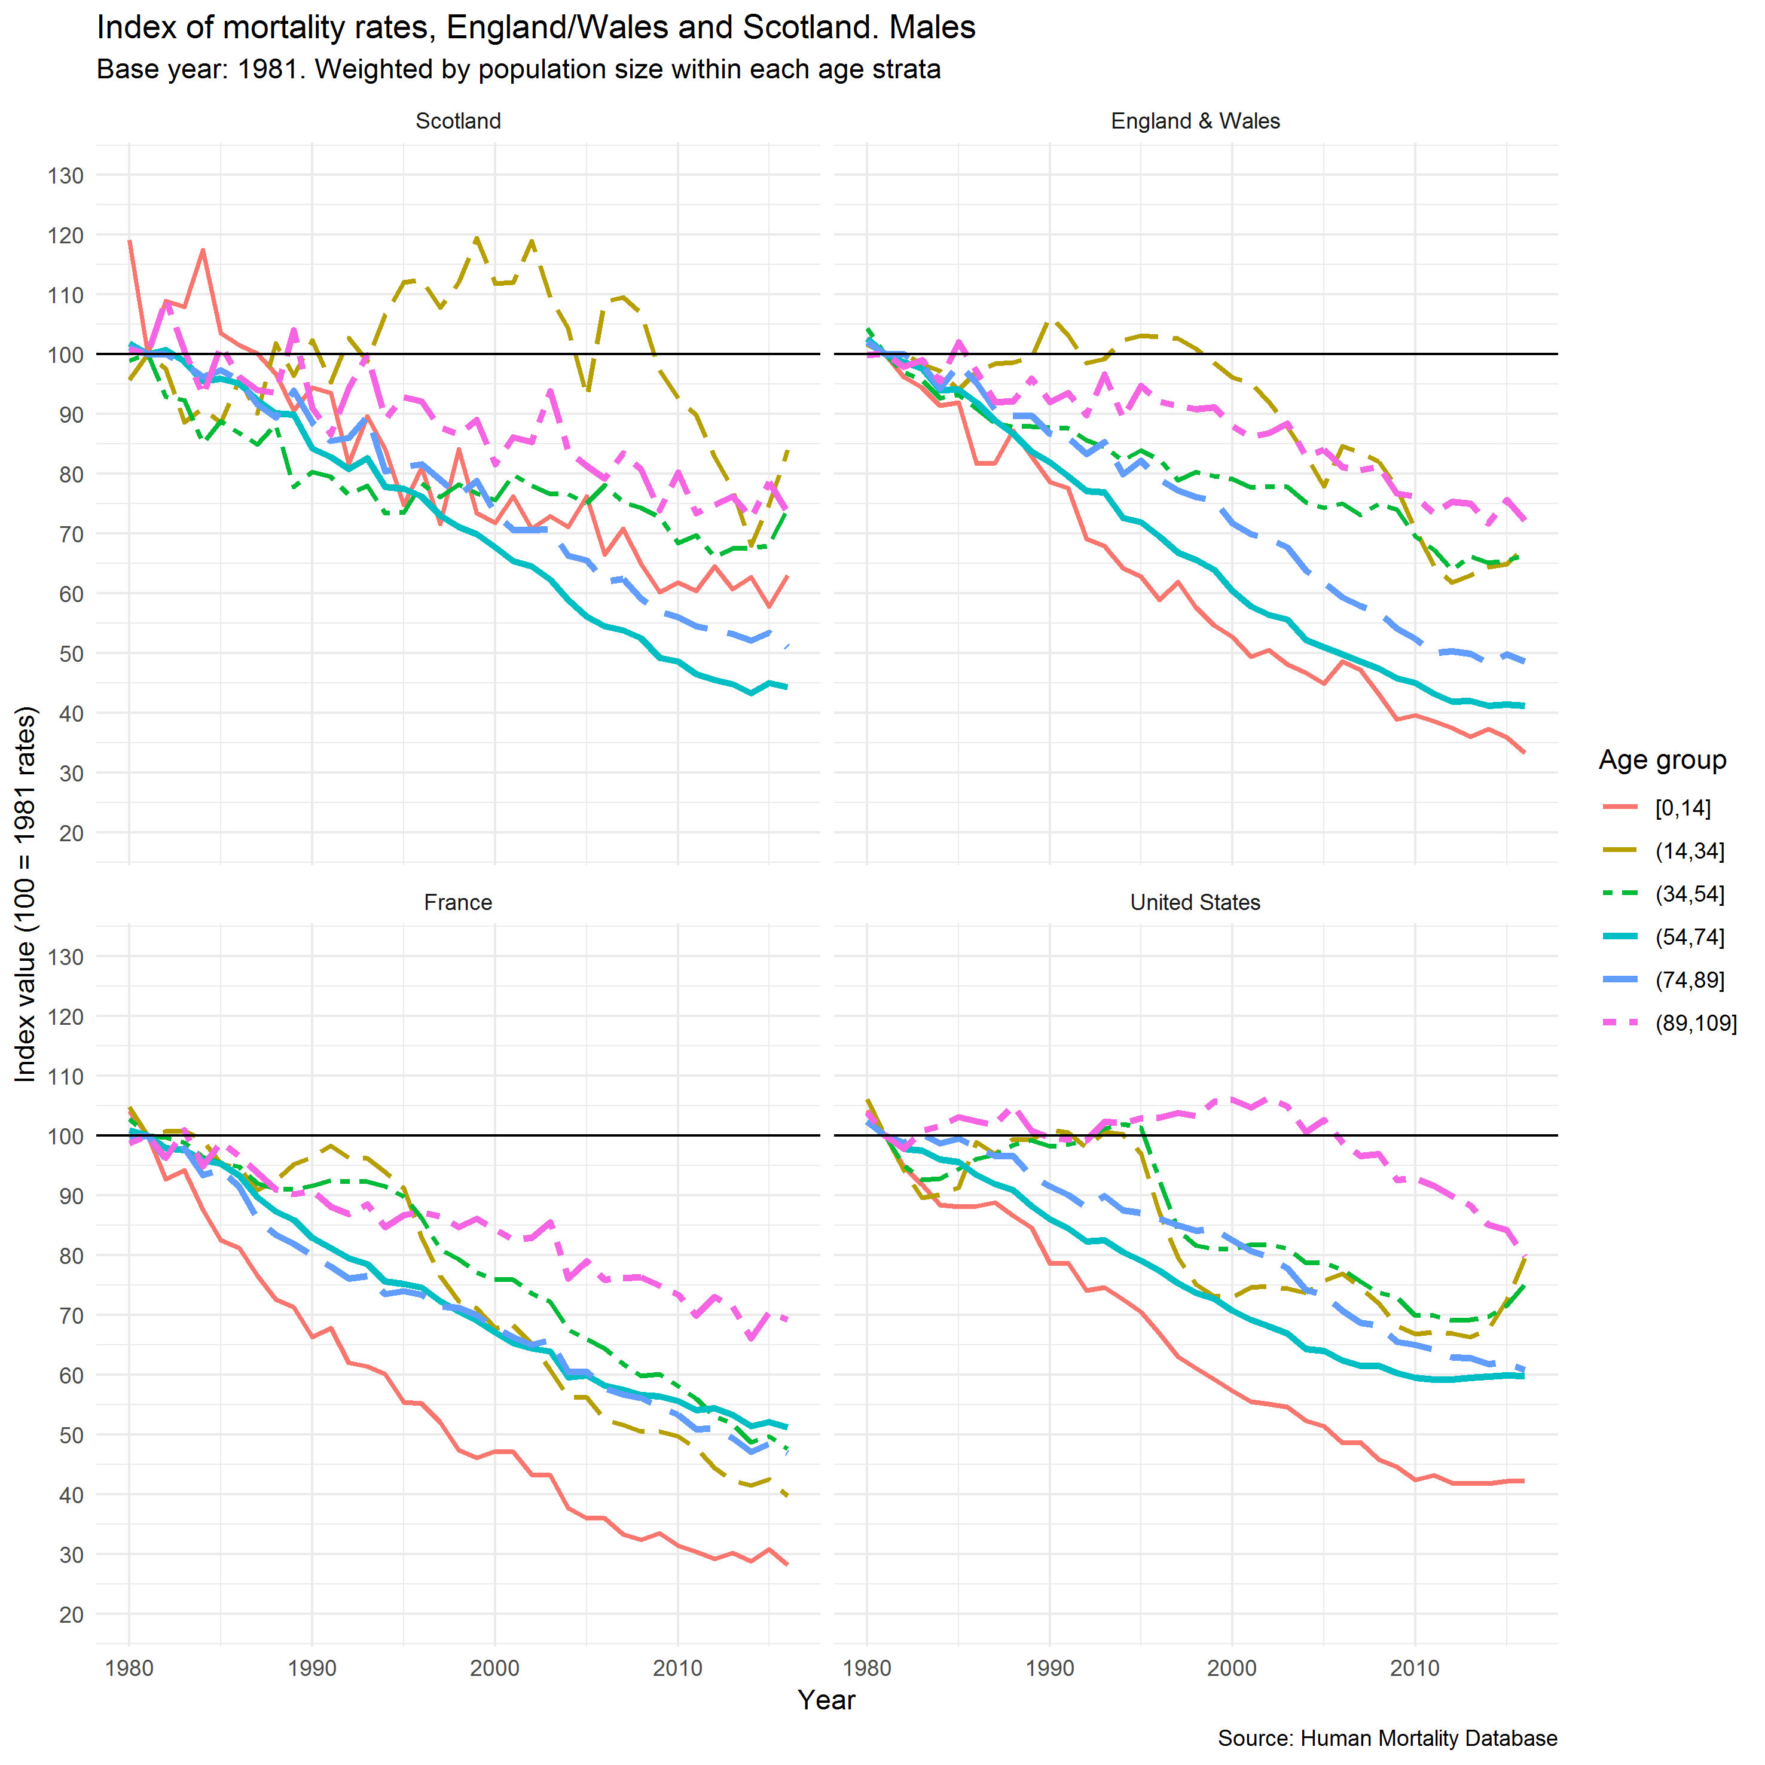

**Segmented regression**

The annual age-standardised mortality rates for males and females in Scotland from 1994 to 2017 are shown in Figure 9. Similar to the trends for life expectancy, there is a suggestion of a change in the trends from around 2011 onwards, although there are earlier periods (1999-2000 and 2001-2003) where there were short-term increases.

**Figure 9 - Age-standardised mortality rate (ESP 2013), Scotland, 1994-2017**

To determine when the recent mortality trends changed, a one- and two-break segmented regression model was fitted to the quarterly rolling age-standardised mortality data between 1990 and 2017. The best fit breakpoint in the all-ages trends for men was in the four quarters leading up to September 2013 (give confidence interval); and for women was in the four quarters up to June 2014 (give confidence interval) (Figure 10). When the population was divided into <75years and 75+ years, the breakpoints were found to be slightly earlier for younger men than older men (X (CI) and Y (CI) respectively) and substantially earlier for younger women than older women (X (CI) and Y (CI) respectively) (Figure 11). In the two-break models (Figure 12), there is a consistent break-point between 2011 and 2014 for men and women for all ages, <75year-olds and those aged 75+ years. The additional break-point for men is in the early 1990s, heralding the beginning of a period of faster improvement. The earlier break-point in women was in the early 1990s for women of all ages, but 2003-2006 for the stratified estimates (although these were imprecise). Although there are fewer deaths in the younger age groups, the estimates are more precise because the underlying trends are more stable than for those aged 75+ years.

**Figure 10 – Age-standardised quarterly mortality rates (rolling over four data points) with one-break segmented regression model fitted, Scotland, 1990-2017**

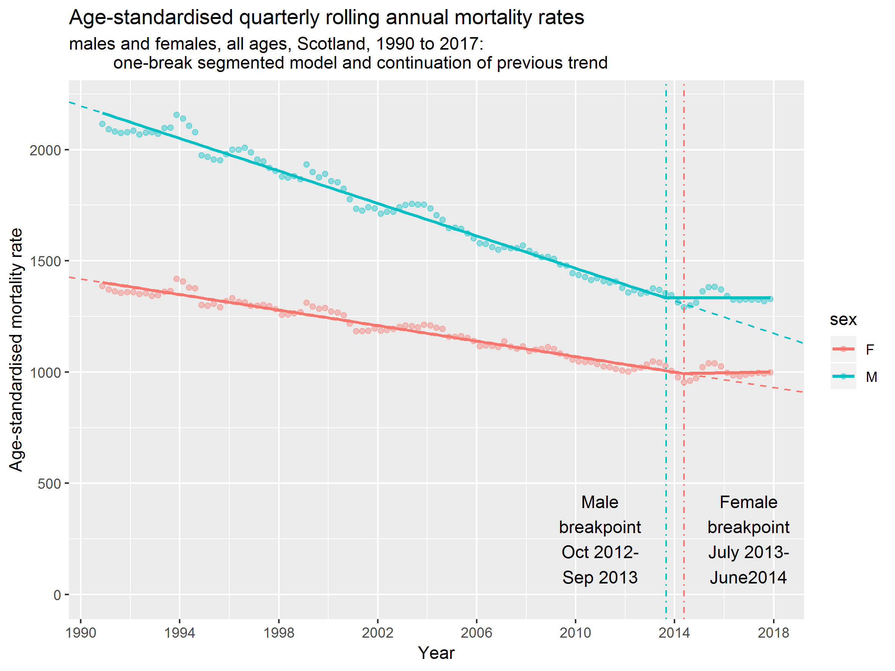

**Figure 11 - One breakpoint model: breakpoint identified by one breakpoint segmented regression of age standardised mortality rate (ESP 2013), by age group and sex, Scotland 1990(Q1)-2018(Q2)**

**Figure 12 - Two breakpoint model: breakpoint identified by one breakpoint segmented regression of age standardised mortality rate (ESP 2013), by age group and sex, Scotland 1990(Q1)-2018(Q2)**

**Discussion**

**Main results**

Life expectancy in Scotland has generally increased since 1855 for males and females, but have increased at different rates over time.

Add age index analysis

The annualised rate of increase was greatest between 1892 and 1956, albeit with large declines in 1897-1901 and 1937-1941 for men, with smaller and steadier increases from 1957 onwards. Between 2012 and 2016 the increases were only 2.5 weeks/year for women and 4.5 weeks for men. Of 13 high income countries, only England & Wales and the USA saw smaller increases than Scotland over this time period. The rate of increase was highly variable across countries, with several countries experiencing markedly lower increases than in previous time periods (notably the USA, England & Wales, Scotland and the Netherlands) and several with similar (Poland, Denmark, Czech Republic) or even greater (Japan and Belarus) than in 1997-2011. The recent mortality trends in Scotland changed from their previous trends for men in the year to September 2013, and for women in the year to June 2014, if it is assumed there is a single turning point between Q1 in 1990 and Q2 in 2018. If it is assumed there is are two turning points, recognising that the rate of improvement was more rapid during the late 1990s and 2000s than before or after, turning points were consistently identified between 2011 and 2015.

**Strengths**

Sensitivity analyses

**Limitations**

**How this fits**

The recent stalled improvement of life expectancy trends across many high income countries is now well recognised.5-6789101112 The turning point in the mortality trends occurred at a similar time in Scotland to those in England for the total population, but slightly later than in England when the data are age-stratified.7 Various hypotheses have been proposed to explain these trends, but in particular influenza and austerity.

Some of the influenza surveillance systems detected large increases in crude mortality during the first half of 2015, and in the first few months of 2017 and 2018.13 [21] Cause-specific mortality rates for influenza and respiratory conditions were also responsible for part of the increases in mortality rates during this time period. The surveillance data for influenza-like illness (ILI) collected through healthcare systems and laboratory testing did not consistently indicate particularly substantial influenza seasons13 21 and the extended period over which mortality rates remained high make influenza less likely to be an important explanation across all countries and time periods.

It is possible that influenza and aspects of political economy are both causal, perhaps with influenza as a biological mechanism linking such exposures to mortality. An important exposure is the financial crisis which spread across the world in 2008 which led to a marked economic recession in many countries. Given that unemployment and income are important determinants of health,[22] the potential for the crisis to adversely impact on mortality was highlighted early.[23] However, the evidence around the impact of economic recession on health and mortality of populations, rather than individuals, is complex and contested.[24]

The response to the financial crises from 2008 across many countries was to implement a range of austerity policies whereby public spending was reduced in the pursuit of balanced budgets or even budgetary surpluses. Where money was created, as with the quantitative easing policies in the USA and UK, this was generally used to refinance the banks rather than to protect public services. As a result, a very wide range of public services experienced substantial reductions in their budgets and public sector wages and income transfers to lower income groups were frequently reduced in real terms. There is evidence that this impacted on a range of health outcomes, but not always consistently or negatively.[25]

A particular aspect of austerity in the UK has been the very substantial reductions in budget available to local government. This impacts on a wide range of services, but a particular proposed mechanism has been through reduction in the budget available to provide social care services, something that is largely delivered to the elderly either living at home or in residential accommodation.12 [26] [27] It has been suggested that this meant that fewer people could be adequately cared for outside of the NHS, leading to lower quality care and increased demand on hospital services. Areas with the largest reductions in spending in England had the greatest mortality increases.[28] It has also been proposed that the increased segregation of society, associated with rising income inequality, has also contributed to social isolation and loneliness that has exacerbated the impact of service reductions.[29]

Another specific aspect of austerity in several countries has been changes to social security to reduce the real-terms value of benefits, reduce their coverage and eligibility, and to increase the range of conditions placed on their receipt. In the UK it was proposed that this would impact most on working-age adults, although child poverty has also seen marked rises and many of the proposed changes have yet to have fully worked through with large rises in income inequality and poverty projected for the future.[30] There is some ecological evidence that this has negatively impacted on some aspects of health in Scotland, including mortality rates for those aged 50-74 years.12

Other hypotheses have also been proposed. During the rise in obesity in most high income countries, epidemiologists warned that this might result in increases in a range of conditions such as Type II diabetes, osteoarthritis and cancer, and through these mechanisms, mortality.[31] Another factor that may be relevant is the increases in the age at which people are entitled to pensions, perhaps by putting the population reaching the previous retirement age in the position of having to work longer than would otherwise have been the case. This could operate through various mechanisms: lower incomes; the impact on biology of working at an older age; or through the diversion from caring duties, family support or volunteering towards paid work. Pensioner poverty rates and the value of social security payments for pensions are also likely to be important.28 [32]

**Implications**

Further work – detail next analysis steps

**Conclusion**

tbc

**Competing interests**

The authors declare that they have no competing interests. No funding was received for this work.

**Funding**

No funding was received for this work. GM, LF and JM are salaried by the NHS and JR and MK are salaried by NRS.

**Contributor statement**

GM drafted the manuscript. LF, JM, JR and MK undertook the analyses. All authors made substantial contributions to editing the manuscript and approved the final draft.

**References**

1. McCartney G, Walsh D, Whyte B, Collins C. Has Scotland always been the ‘sick man’ of Europe? European Journal of Public Health 2012; 22(6): 756–760.
2. Minton J, Vanderbloemen L, Dorling D. Visualizing Europe’s demographic scars with coplots and contour plots. International Journal of Epidemiology 2013; 42(4): 1164–1176, <https://doi.org/10.1093/ije/dyt115>.
3. Leon, DA. Trends in European life expectancy: a salutary view. International Journal of Epidemiology 2011; 40(2): 271–277, <https://doi.org/10.1093/ije/dyr061>.
4. Minton J, Shaw R, Green M, Vanderbloemen L, Popham F, McCartney G. Visualising and quantifying ‘excess deaths’ in Scotland compared with the rest of the UK and the rest of Western Europe. J Epidemiology and Community Health 2017; 71: 461-467, doi: 10.1136/jech-2016-207379.
5. Ho JY, Hendi AS. Recent trends in life expectancy across high income countries: retrospective observational study. BMJ 2018; 362: k2562, <http://dx.doi.org/10.1136/bmj.k2562>.
6. Changing trends in mortality: an international comparison: 2000 to 2016. Analysis of period life expectancies and mortality in selected countries globally from 2000 to 2016. London, Office for National Statistics, 2018.
7. Changing trends in mortality: a cross-UK comparison, 1981 to 2016. Analysis of age-specific and age-standardised mortality rates for the UK, England, Wales, Scotland and Northern Ireland from 1981 to 2016. London, Office for National Statistics, 2018.
8. Minton, J., Shaw, R., Green, M., Herdman, J., Vanderbloemen, L., McCartney, G. Two cheers for a Small Giant? Why we need better ways of seeing data. A commentary on: ‘Rising morbidity and mortality in midlife among white non-Hispanic (WNH) Americans in the 21st century'. International Journal of Epidemiology 2017; 46(1): 356-361, doi: 10.1093/ije/dyw095.
9. Fransham M, Dorling D. Have mortality improvements stalled in England?: same data—different stories. BMJ 2017; 357: j1946 doi: 10.1136/bmj.j1946.
10. Hiam L, Dorling D. Rise in mortality in England and Wales in first seven weeks of 2018. BMJ 2018; 360, k1090, doi: <https://doi.org/10.1136/bmj.k1090>.
11. Woolf SH, Chapman DA, Buchanich JM, Bobby KJ, Zimmerman EB, Blackburn SM. Changes in midlife death rates across racial and ethnic groups in the United States: systematic analysis of vital statistics. BMJ 2018; 362: k3096, <http://dx.doi.org/10.1136/bmj.k3096>.
12. Taulbut M, Agbato D, McCartney G. Working and hurting? Monitoring the health and health inequalities impacts of the economic downturn and changes to the social security system. Glasgow, NHS Health Scotland, 2018.
13. Vestergaard LS, Jens Nielsen J, Tyra G Krause TG, et al. Excess all-cause and influenza-attributable mortality in Europe, December 2016 to February 2017. Eurosurveillance 2017; 22(14), <https://doi.org/10.2807/1560-7917.ES.2017.22.14.30506>.
14. Bradford-Hill A. The Environment and Disease: Association or Causation? Proceedings of the Royal Society of Medicine 1965; 58(5): 295–300.
15. Parkinson J, Minton J, Lewsey J, Bouttell J, McCartney G. Recent cohort effects in suicide in Scotland: a legacy of the 1980s? J Epidemiology and Community Health 2017; 71: 194-200.
16. Parkinson P, Minton M, Lewsey J, Bouttell J, McCartney G. Drug-related deaths in Scotland 1979–2013: evidence of a vulnerable cohort of young men living in deprived areas. BMC Public Health (2018) 18:357, https://doi.org/10.1186/s12889-018-5267-2.
17. Minton J, Shaw R, Green M, Vanderbloemen L, Popham F, McCartney G. Visualising and quantifying ‘excess deaths’ in Scotland compared with the rest of the UK and the rest of Western Europe. J Epidemiology and Community Health 2017; 71: 461-467, doi: 10.1136/jech-2016-207379.
18. McCartney G, Bouttell J, Craig N, Craig P, Graham L, Lakha F, Lewsey J, McAdams R, MacPherson M, Minton J, Parkinson J, Robinson M, Shipton D, Taulbut M, Walsh D, Beeston C. Explaining trends in alcohol-related harms in Scotland, 1991-2011 (I): the role of incomes, effects of socio-economic and political adversity and demographic change. Public Health 2016; 132: 13-23.
19. Benchimol EI, Smeeth L, Guttmann A, Harron K, Moher D, Petersen I, et al. The REporting of studies Conducted using Observational Routinely-collected health Data (RECORD) Statement. PLoS Med 2015; 12(10): e10018.
20. Human Mortality Database. University of California, Berkeley (USA), and Max Planck Institute for Demographic Research (Germany). Available at www.mortality.org or www.humanmortality.de (data downloaded on [date]).
21. Mølbak K, Espenhain L, Nielsen J. Excess mortality among the elderly in European countries, December 2014 to February 2015. Euro Surveill. 2015; 20(11), <https://doi.org/10.2807/1560-7917.ES2015.20.11.21065>.
22. Roelfs DJ, Shor E, Davidson KW, Schwartz JE. Losing life and livelihood: a systematic review and meta-analysis of unemployment and all-cause mortality. Social Science Medicine 2011; 72(6): 840-54, doi: 10.1016/j.socscimed.2011.01.005.
23. Marmot MG, Bell R. How will the financial crisis affect health? BMJ 2009; 338: b1314, doi: <https://doi.org/10.1136/bmj.b1314>.
24. Tapia Granados JA, Ionides EL. Population health and the economy: Mortality and the Great Recession in Europe. Health Economics 2017; 26:e219–e235.
25. Parmar D, Stavropoulou C, Ioannidis JPA. Health outcomes during the 2008 financial crisis in Europe: systematic literature review. BMJ 2016; 354, i4588, doi: <https://doi.org/10.1136/bmj.i4588>.
26. Hiam L, Dorling D, McKee M. The cuts and poor health: when and how can we say that one thing causes another? Journal of the Royal Society of Medicine; 2018, Vol. 111(6) 199–202, doi: 10.1177/0141076818779237.
27. Watkins J, Wulaningsih W, Da Zhou C, et al Effects of health and social care spending constraints on mortality in England: a time trend analysis BMJ Open 2017;7:e017722. doi: 10.1136/bmjopen-2017-017722.
28. Loopstra R, Reeves A, Barr B, Taylor-Robinson D, McKee M, Stuckler D. The impact of economic downturns and budget cuts on homelessness claim rates across 323 local authorities in England, 2004–12. Journal of Public Health; 38(3): 417–425, doi:10.1093/pubmed/fdv126.
29. Dorling D. Dying Quietly: English Suburbs and the Stiff Upper Lip. The Political Quarterly [online first].
30. Hood A, Waters T. Living standards, poverty and inequality in the UK: 2016–17 to 2021–22. London, Institute for Fiscal Studies, 2017.
31. Olshanksy SJ, Passaro DJ, Hershow RC. A Potential Decline in Life Expectancy in the United States in the 21st Century. N Engl J Med 2005; 352:1138-1145, doi: 10.1056/NEJMsr043743.
32. Fransham M, Dorling D. Have mortality improvements stalled in England? Same data—different stories. BMJ 2017; 357: j1946, doi: 10.1136/bmj.j1946.